Table of Contents

Chapter 1. Introduction Page No.
- Introduction to the System 4
- Problem Definition 4
- Aim 4
- Objective 4
- Goal 5
- Need of System 5

Chapter 2. Hardware and Software requirement
- Introduction 7
- System environment 7
- Software requirement 8
- Hardware requirements 8

Chapter 3. System Analysis
- Purpose 9
- Project Scope 9
- Existing System 9
- Proposed System 9
- System Description 10

Chapter 4.Implementation issues

- Python 11
- HTML 13
- Cascading style sheet(CSS) 16
- SQLITE 17

Chapter 5. System Design
- Introduction 21
- Conceptual Design 22
- ER-Diagram 23
- Logical Design 23
- Physical Design 24
- Data Flow Diagram 24

Chapter 6.User Screens 25-32

Chapter 7.Coding 33-67

Chapter 8. Conclusion
- Features of “Smart Health Prediction” 68
- Benefits Accrued from “Smart Health Prediction” 69
- Limitations of “Smart Health Prediction” 70

Bibliography

CHAPTER # 1

Introduction
Contents:
- Introduction
- Problem Definition
- Aim
- Objective
- Goal
- Need of System

Introduction to the System:

It might have happened so many times that you or someone yours need doctors help immediately, but they are not available due to some reason. The Health Prediction system is an end user support and online consultation project. Here we propose a system that allows users to get instant guidance on their health issues through an intelligent health care system online. The system is fed with various symptoms and the disease/illness associated with those systems. The system allows user to share their symptoms and issues. It then processes user’s symptoms to check for various illnesses that could be associated with it. Here we use some intelligent data mining techniques to guess the most accurate illness that could be associated with patient’s symptoms. In doctor module when doctor login to the system doctor can view his patient details and the report of that patient. Doctor can view details about the patient search what patient searched for according to their prediction. Doctor can view his personal details. Admin can add new disease details by specifying the type and symptoms of the disease into the database. Based on the name of the disease and symptom the data mining algorithm works. Admin can view various disease and symptoms stored in database. This system will provide proper guidance when the user specifies the symptoms of his illness.

Problem Definition:

Prediction of health disease may seem tricky, but this is part of user service system (application support direct contact with user).

Aim:

To predict health disease according symptops stored in database.

Objective:

The objective of this project entitled “Smart health disease prediction using data mining” is to provide a user friendly and easily understandable GUI to users to easily get instant guidance on their health issues through an intelligent health care system online. The main objective of the System is to predict disease according to symptoms and also suggest list of doctors and medicines.

Goal:

- User can search for doctor’s help at any point of time.
- User can talk about their illness and get instant diagnosis.
- Informs the user about the type of disease or disorder it feels.
- Doctors get more clients online.

Need of the System:

There is always a need of a system that will provide the disease information according to symptoms shared by user.
This system will help the user to find good doctors and medicines.

CHAPTER # 2
Hardware and Software Requirements

Contents:
- Software requirement
- Hardware requirements

Software Requirements:

- Technology: Python Django
- IDE : Pycharm/Atom
- Client Side Technologies: HTML, CSS, JavaScript , Bootstrap
- Server Side Technologies: Python
- Data Base Server: Sqlite
Operating System: Microsoft Windows/Linux

Hardware Requirements:

- Processor: Pentium-III (or) Higher
- Ram: 64MB (or) Higher
- Hard disk: 80GB (or) Higher

CHAPTER # 3
System Analysis

Contents:

Purpose
- Project Scope
- Existing System
- Proposed System
- System Overview

Purpose:

- User can search for doctor’s help at any point of time.
- User can talk about their illness and get instant diagnosis.
- Informs the user about the type of disease or disorder it feels.
- Doctors get more clients online.

Project Scope:

The project has a wide scope, as it is not intended to a particular organization. This project is going to develop generic software, which can be applied by any businesses organization. More over it provides facility to its users. Also the software is going to provide a huge amount of summary data.

Proposed System:

To beat the downside of existing framework we have created smart health prediction System. We have built up a specialist framework called Smart Health Prediction framework, which is utilized for improving the task of specialists. A framework checks a patient at initial level and proposes the possible diseases. It begins with getting some information about manifestations to the patient, in the event that the framework can distinguish the fitting sickness, at that point it proposes a specialist accessible to the patient in the closest conceivable territory. On the off chance that the framework isn't sufficiently sure, it asks few questions to the patients, still on the off chance that the framework isn't sure; at that point it will show a few tests to the patient. In light of accessible total data, the framework will demonstrate the result. Here we utilize some intelligent methods to figure the most precise disorder that could be associated with patient's appearances and dependent on the database of a couple of patients restorative record, calculation (Naïve Bayes) is connected for mapping the side effects with conceivable diseases.This framework improves undertaking of the specialists as well as helps the patients by giving vital help at a soonest organize conceivable.

System Overview:

- Patient Login: - Patient Login to the system using his ID and Password.
- Patient Registration: -If Patient is a new user he will enter his personal details and he will user Id and password through which he can login to the system.
- My Details: - Patient can view his personal details.
- Disease Prediction: - Patient will specify the symptoms caused due to his illness. System will ask certain question regarding his illness and system predict the disease based on the symptoms specified by the patient and system will also suggest doctors based on the disease.
- Search Doctor:- Patient can search for doctor by specifying name, address or type.
- Feedback:-Patient will give feedback this will be reported to the admin.
- Doctor Login: - Doctor will access the system using his User ID and Password.
- Patient Details: Doctor can view patient’s personal details.
- Notification: Doctor will get notification how many people had accessed the system and what all are the diseases predicted by the system.
- Admin Login: Admin can login to the system using his ID and Password.
- Add Doctor: Admin can add new doctor details into the database.
- Add Disease: Admin can add disease details along with symptoms and type.
- View Doctor: Admin can view various Doctors along with their personal details.
- View Disease: Admin can view various diseases details stored in database.
- View Patient: Admin can view various patient details who had accessed the system.
- View Feedback: Admin can view feedback provided by various users.

CHAPTER # 4
Implementation issues

Python

Python is a widely used general-purpose, high level programming language. It was initially designed by Guido van Rossum in 1991 and developed by Python Software Foundation. It was mainly developed for emphasis on code readability, and its syntax allows programmers to express concepts in fewer lines of code.
Python is a programming language that lets you work quickly and integrate systems more efficiently.
Python is dynamically typed and garbage-collected. It supports multiple programming paradigms, including procedural, object-oriented, and functional programming. Python is often described as a "batteries included" language due to its comprehensive standard library.

HTML

HTML (Hypertext Markup Language) is the set of markup symbols or codes inserted in a file intended for display on a World Wide Web browser page. The markup tells the Web browser how to display a Web page's words and images for the user. Each individual markup code is referred to as an element (but many people also refer to it as a tag). Some elements come in pairs that indicate when some display effect is to begin and when it is to end.

CASCADING STYLE SHEET (CSS)

Cascading Style Sheets (CSS) are a collection of rules we use to define and modify web pages. CSS are similar to styles in Word. CSS allow Web designers to have much more control over their pages look and layout. For instance, you could create a style that defines the body text to be Verdana, 10 point. Later on, you may easily change the body text to Times New Roman, 12 point by just changing the rule in the CSS. Instead of having to change the font on each page of your website, all you need to do is redefine the style on the style sheet, and it will instantly change on all of the pages that the style sheet has been applied to. With HTML styles, the font change would be applied to each instance of that font and have to be changed in each spot.

CSS can control the placement of text and objects on your pages as well as the look of those objects.

HTML information creates the objects (or gives objects meaning), but styles describe how the objects should appear. The HTML gives your page structure, while the CSS creates the “presentation”. An external CSS is really just a text file with a .css extension. These files can be created with Dreamweaver, a CSS editor, or even Notepad.

The best practice is to design your web page on paper first so you know where you will want to use styles on your page. Then you can create the styles and apply them to your page.

Javascript

JavaScript is a programming languagecommonly used in web development. It was originally developed by Netscape as a means to add dynamic and interactive elements to websites. While JavaScript is influenced byJava, the syntax is more similar to C and is based on ECMAScript, a scripting language developed by Sun Microsystems.
JavaScript is a client-side scripting language, which means the source code is processed by the client's web browser rather than on the web server. This means JavaScript functions can run after a webpage has loaded without COMMUNICATING with the server. For example, a JavaScript function may check a web form before it is submitted to make sure all the required fields have been filled out. The JavaScript code can produce an error message before any information is actually transmitted to the server.
Like server-side scripting languages, such as PHP and ASP, JavaScript code can be inserted anywhere within the HTML of a webpage. However, only the output of server-side code is displayed in the HTML, while JavaScript code remains fully visible in the source of the webpage. It can also be referenced in a separate .JS file, which may also be viewed in a browser.

Django

Django is a web application framework written in Python programming language. It is based on MVT (Model View Template) design pattern. The Django is very demanding due to its rapid development feature. It takes less time to build application after collecting client requirement.
This framework uses a famous tag line: The web framework for perfectionists with deadlines.

CHAPTER # 5
System Design

Contents:

- Use case diagram
- Class Diagram
- Sequence Diagram
- Data flow diagram

Use Case Diagram:
- Use case diagram consists of use cases and actors and shows the interaction between them. The key points are:
- The main purpose is to show the interaction between the use cases and the actor.
- To represent the system requirement from user’s perspective.
- The use cases are the functions that are to be performed in the module.

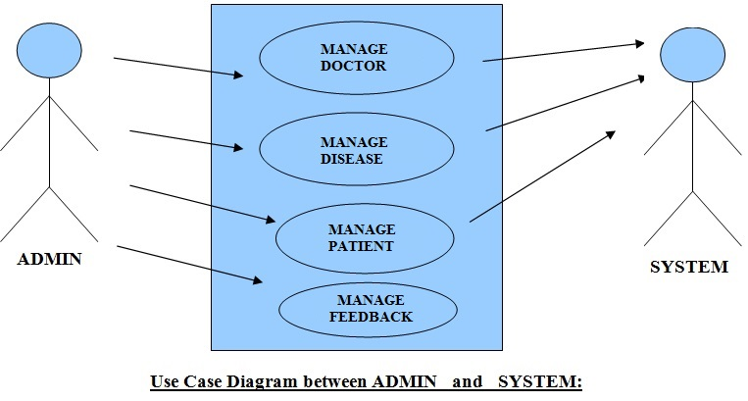

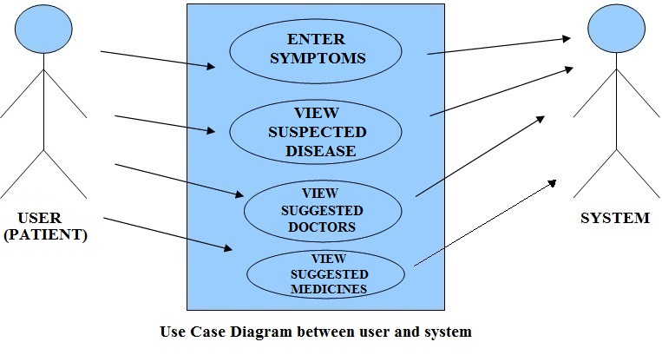

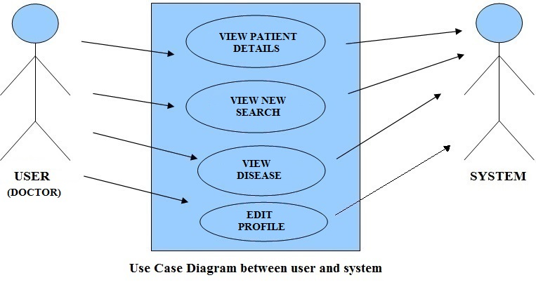

Sequence Diagram For Administrator:-

Login
Application
Database
Login
:Request
:Validate()
:executeQuery()
Response
Show Result
Failed:show()
Administrator
Success:hide()

Fig.5.4

Sequence Diagram For User:-

Login
Application
Database
Login
:Request
:Validate()
:executeQuery()
Response
Show Result
User
Success:hide()
Failed:show()

Fig.5.5

Data Flow Diagram
A Data Flow Diagram (DFD) is a graphical representation of the "flow" of data through an Information System. A data flow diagram can also be used for the visualization of Data Processing. It is common practice for a designer to draw a context-level DFD first which shows the interaction between the system and outside entities. This context-level DFD is then "exploded" to show more detail of the system being modeled.
A DFD represents flow of data through a system. Data flow diagrams are commonly used during problem analysis. It views a system as a function that transforms the input into desired output. A DFD shows movement of data through the different transformations or processes in the system.
Dataflow diagrams can be used to provide the end user with a physical idea of where the data they input ultimately has an effect upon the structure of the whole system from order to dispatch to restock how any system is developed can be determined through a dataflow diagram. The appropriate register saved in database and maintained by appropriate authorities.
Data Flow Diagram Notation

Function

File/Database

Input/output

Flow

DFD (Data Flow Diagram)

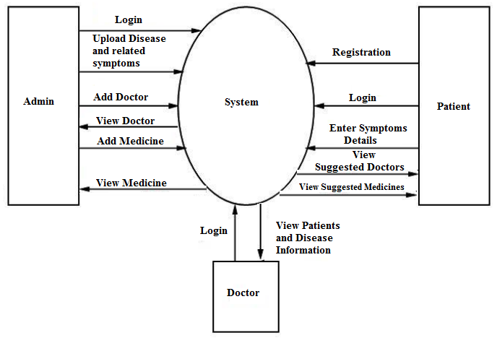

Entity Relationship Diagrams (ER-Diagrams):

An entity-relationship (ER) diagram is a specialized graphic that illustrates the interrelationships between entities in a database. ER diagrams often use symbols to represent three different types of information. Boxes are commonly used to represent entities. Diamonds are normally used to represent relationships and ovals are used to represent attributes
An entity-relationship model (ERM) in software engineering is an abstract and conceptual representation of data. Entity-relationship modeling is a relational schema database modeling method, used to produce a type of conceptual schema or semantic data model of a system, often a relational database, and its requirements in a top-down fashion.
Symbols used in this E-R Diagram:
Entity: Entity is a “thing” in the real world with an independent existence. An entity may be an object with a physical existence such as person, car or employee. Entity symbol is as follows

Attribute: Attribute is a particular property that describes the entity. Attribute symbol is

Relationship: Relationship will be several implicit relationships among various entity types whenever an attribute of one entity refers to another entity type some relationship exits. Relationship symbol is:

Key attributes: An entity type usually has an attribute whose values are distinct for each individual entity in the collection. Such an attribute is called key attribute.

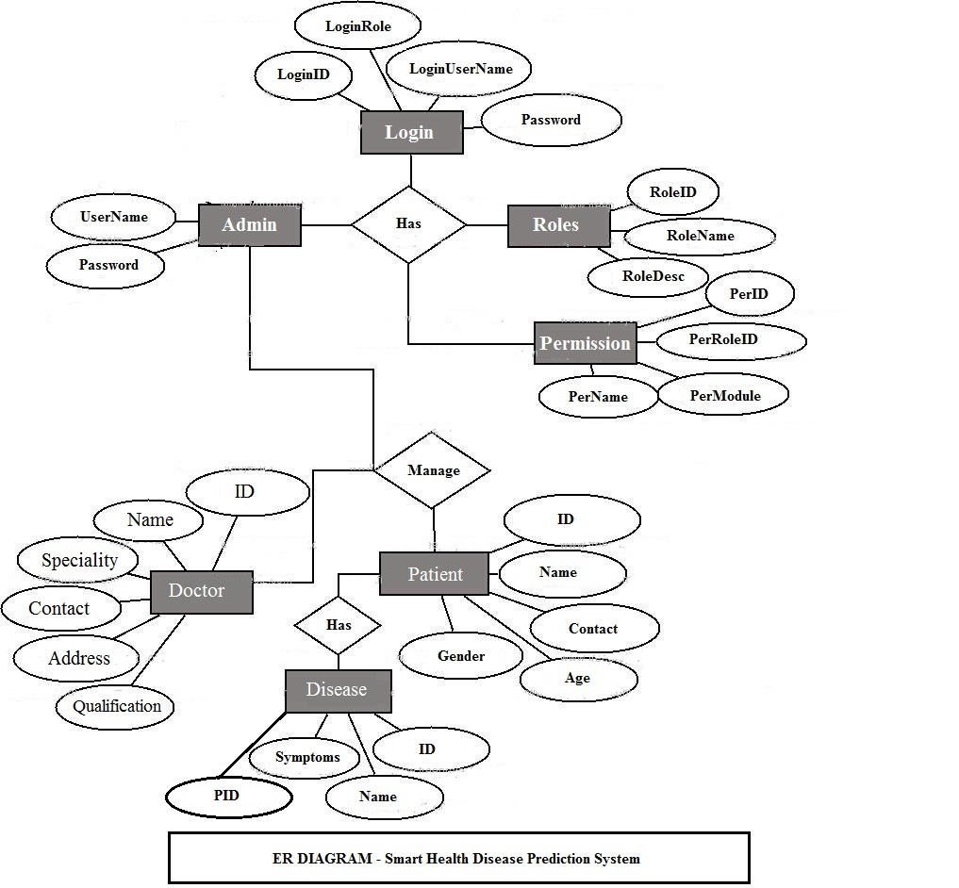

Activity Diagram

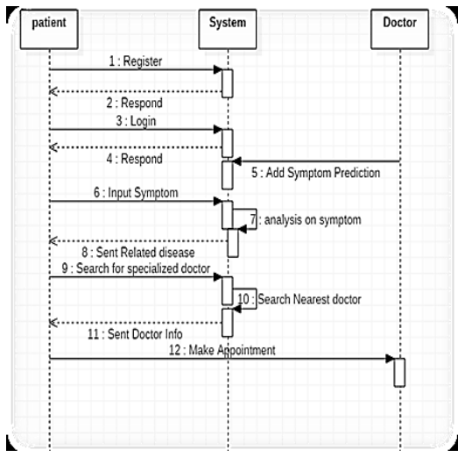

CHAPTER # 6
Output screens
HOME PAGE

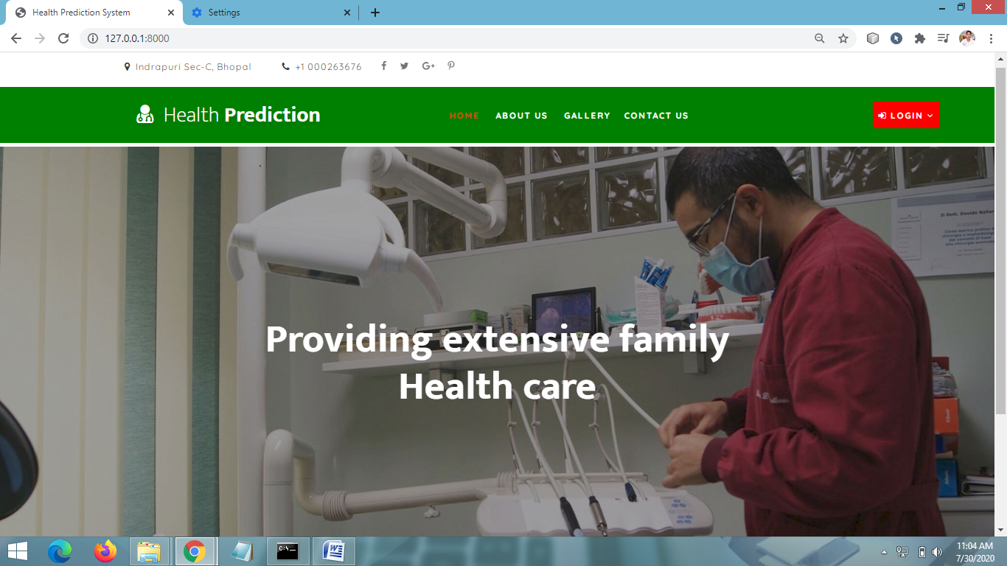

USER (PATIENT) LOGIN PAGE

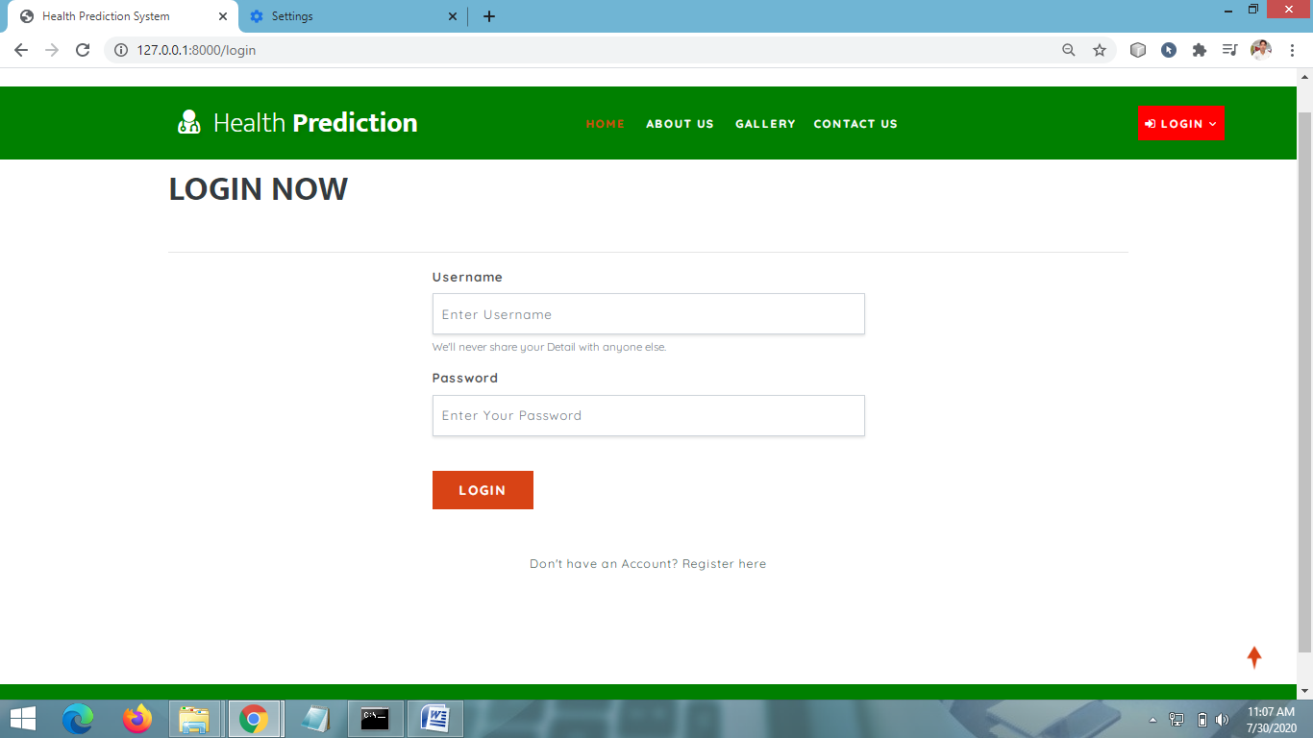

SIGNUP PAGE

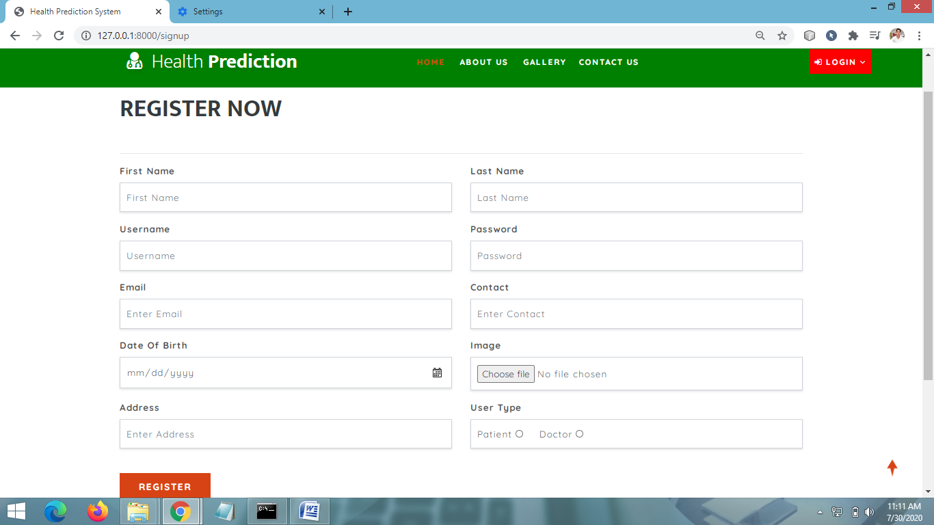

PATIENT HOME PAGE

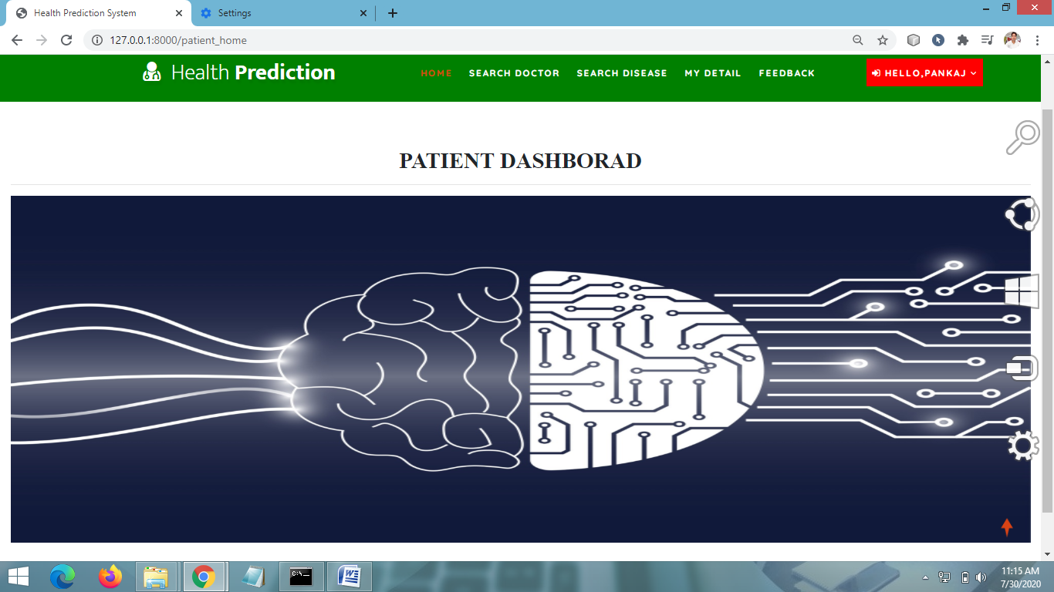

VIEW DISEASE PREDICTION RESULT PAGE

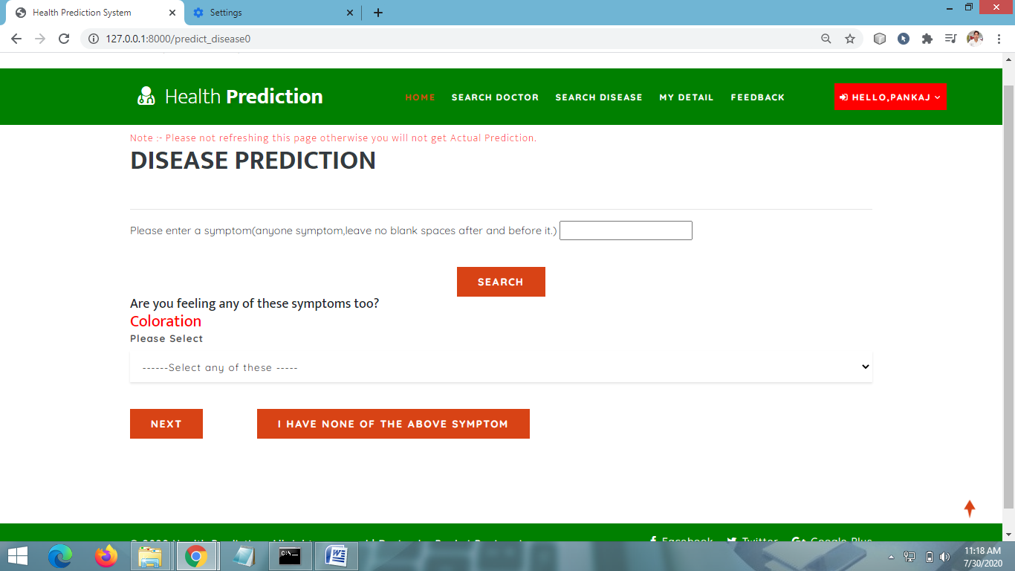

SEARCH DOCTOR PAGE

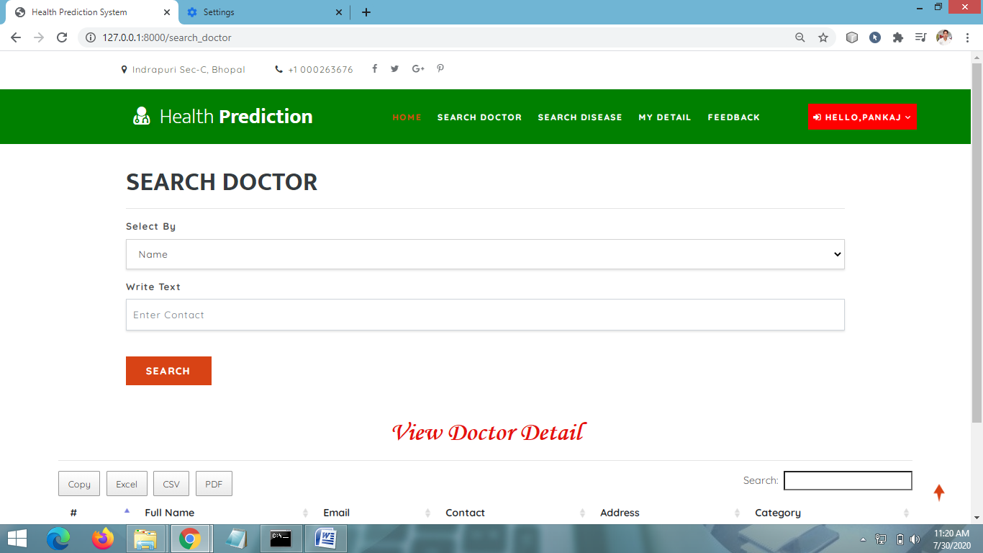

ADMIN HOME PAGE
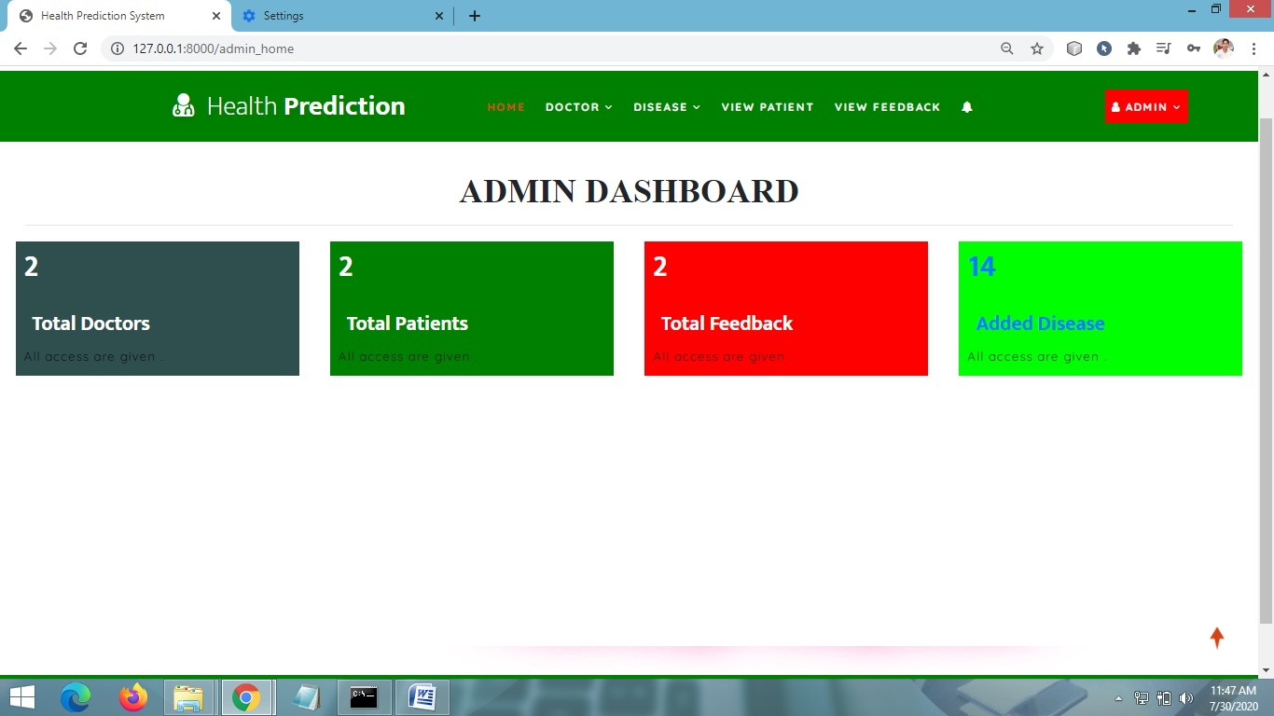

ADD DISEASE INFORMATION PAGE

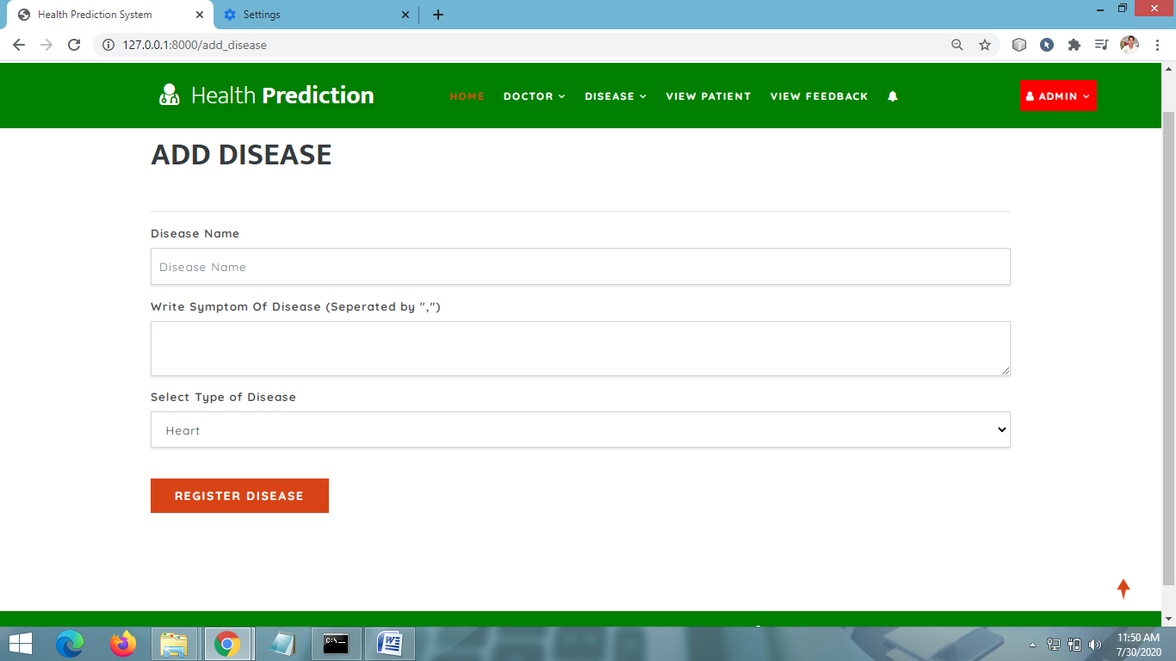

VIEW DISEASE INFORMATION PAGE

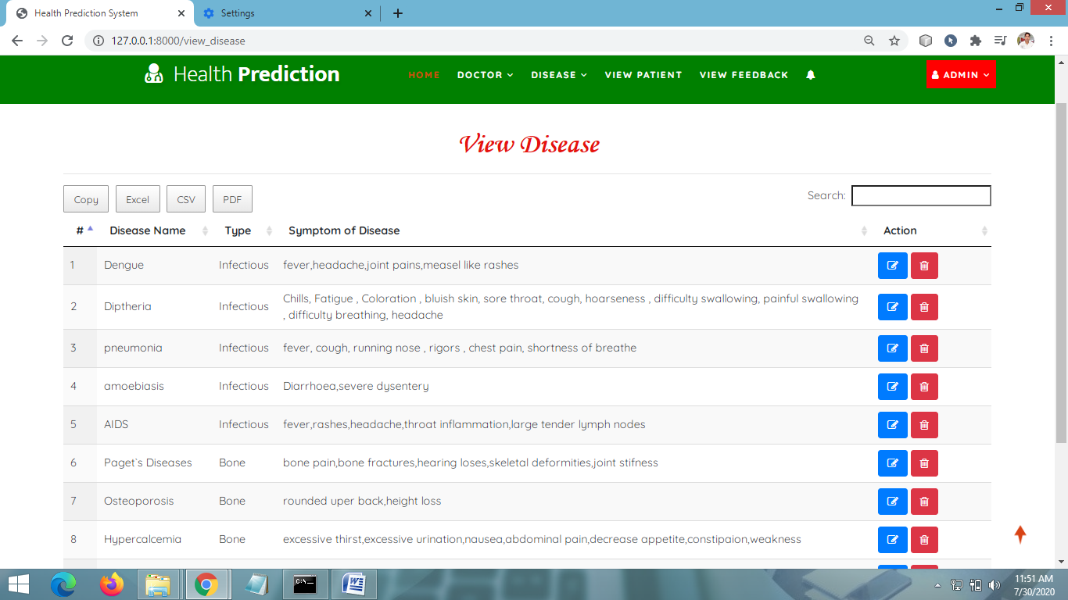

VIEW ALL DOCTORS PAGE

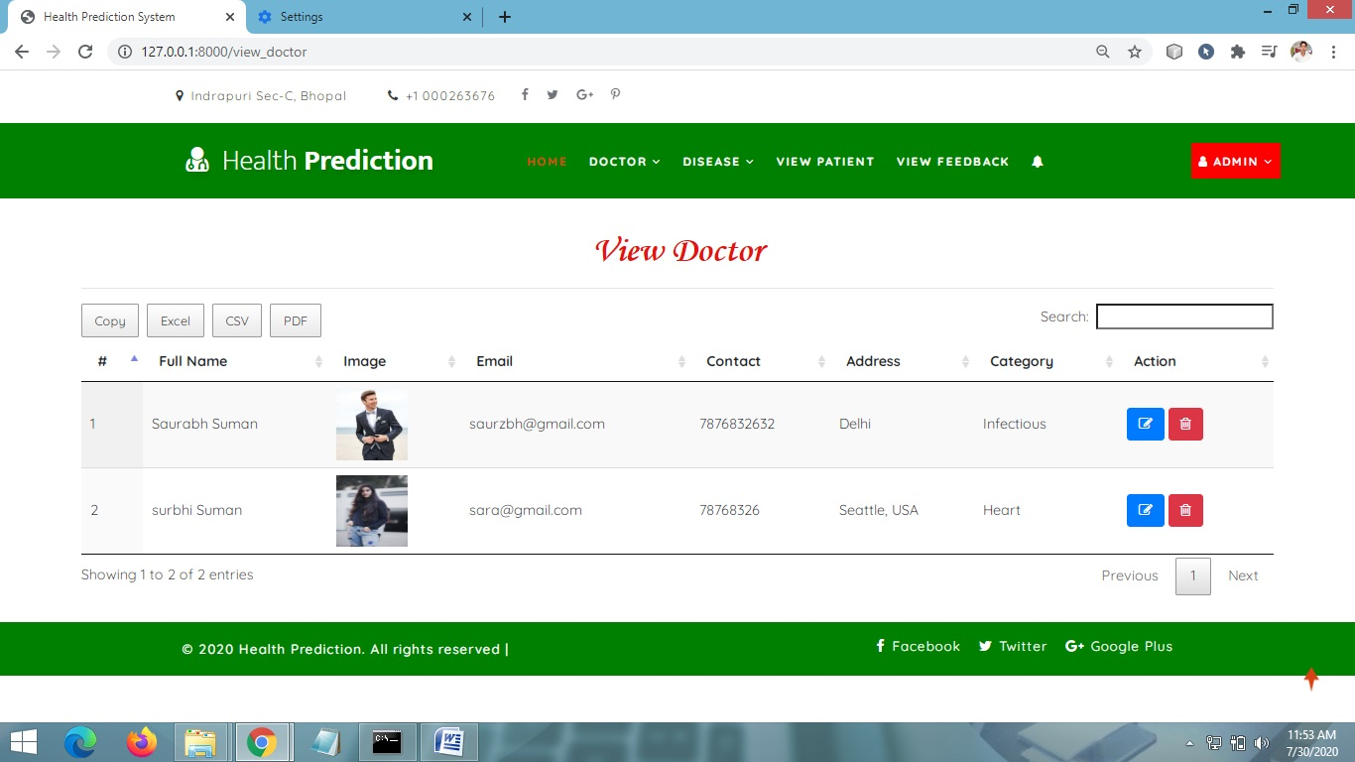

VIEW PATIENTS DETAIL

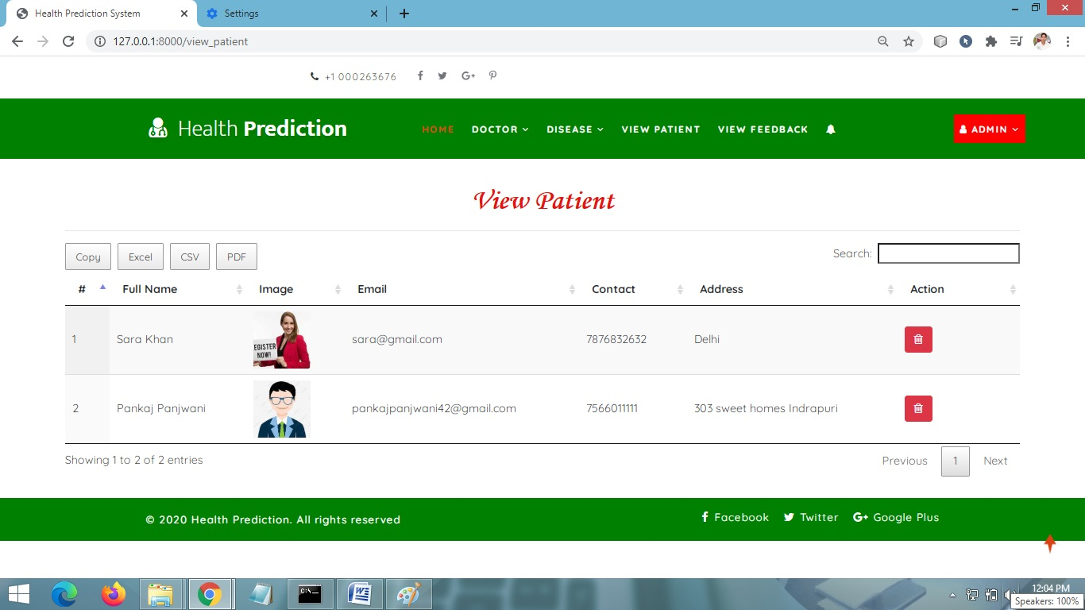

CHAPTER # 7
Coding

HOME PAGE CODING

<!DOCTYPE html>
{% load static %}
<html lang="zxx">

<head>
<title>Health Prediction System</title>
<!-- Meta tag Keywords -->
<meta name="viewport" content="width=device-width, initial-scale=1">
<meta charset="UTF-8" />
<meta name="keywords" />
<script>
addEventListener("load", function () {
setTimeout(hideURLbar, 0);
}, false);

function hideURLbar() {
window.scrollTo(0, 1);
}
</script>
<link rel="stylesheet" href="{% static 'css/bootstrap.css' %}">
<!-- Bootstrap-Core-CSS -->
<link href="{% static 'css/css_slider.css' %}" type="text/css" rel="stylesheet" media="all">
<!-- banner slider -->
<link rel="stylesheet" href="{% static 'css/style.css' %}" type="text/css" media="all" />
<!-- Style-CSS -->
<link href="{% static 'css/font-awesome.min.css' %}" rel="stylesheet">
<!-- Font-Awesome-Icons-CSS -->
<!-- //Custom-Files -->

<!-- Web-Fonts -->
<link href="//fonts.googleapis.com/css?family=Quicksand:300,400,500,700" rel="stylesheet">
<link href="//fonts.googleapis.com/css?family=Mukta:200,300,400,500,600,700,800&amp;subset=devanagari,latin-ext" rel="stylesheet">
<style> <!-- //Web-Fonts -->
.li2{
border:1px solid red;
padding:8px;
}
</style>

<link rel='stylesheet' type='text/css' href="https://cdn.datatables.net/1.10.21/css/jquery.dataTables.min.css">
<link rel='stylesheet' type='text/css' href="https://cdn.datatables.net/buttons/1.6.2/css/buttons.dataTables.min.css">

<script src="https://code.jquery.com/jquery-3.5.1.js"></script>
<script src="https://cdn.datatables.net/1.10.21/js/jquery.dataTables.min.js"></script>
<script src="https://cdn.datatables.net/buttons/1.6.2/js/dataTables.buttons.min.js"></script>
<script src="https://cdnjs.cloudflare.com/ajax/libs/jszip/3.1.3/jszip.min.js"></script>
<script src="https://cdnjs.cloudflare.com/ajax/libs/pdfmake/0.1.53/pdfmake.min.js"></script>
<script src="https://cdnjs.cloudflare.com/ajax/libs/pdfmake/0.1.53/vfs_fonts.js"></script>
<script src="https://cdn.datatables.net/buttons/1.6.2/js/buttons.html5.min.js"></script>

<script>
$(document).ready(function() {
$('#example').DataTable( {
dom: 'Bfrtip',
buttons: [
'copyHtml5',
'excelHtml5',
'csvHtml5',
'pdfHtml5'
]
} );
} );
</script>
</head>

<body>
<!-- main -->
<div id="home" style="margin-bottom:2%">
<!-- top header -->
<header>
<div class="top-bar py-3">
<div class="container">
<div class="row">
<div class="col-xl-6 col-lg-6 col-md-8 top-social-agile text-lg-left text-center">
<div class="row">
<div class="col-5 header-top_w3layouts">
<p class="text-bl">
<span class="fa fa-map-marker mr-2"></span>Indrapuri Sec-C, Bhopal
</p>
</div>
<div class="col-3 header-top_w3layouts">
<p class="text-bl">
<span class="fa fa-phone mr-2"></span>+1 000263676
</p>
</div>
<!-- social icons -->
<ul class="col-4 top-right-info">
<li>
<a href="#">
<span class="fa fa-facebook-f"></span>
</a>
</li>
<li class="mx-3">
<a href="#">
<span class="fa fa-twitter"></span>
</a>
</li>
<li>
<a href="#">
<span class="fa fa-google-plus"></span>
</a>
</li>
<li class="ml-3">
<a href="#">
<span class="fa fa-pinterest-p"></span>
</a>
</li>
</ul>
<!-- //social icons -->
</div>
</div>
<div class="col-xl-7 col-lg-6 col-md-4 top-social-agile text-md-right text-center mt-md-0 mt-2">
<div class="row">
<div class="offset-xl-6 offset-lg-4">
</div>
<div class="col-xl-3 col-lg-4 col-6 top-w3layouts p-md-0 text-right">
<!-- login -->
<a href="login.html" class="login-button-2 text-uppercase text-bl">
</a>
<!-- //login -->
</div>
<div class="col-xl-3 col-lg-4 col-6 header-w3layouts text-md-right text-left">
<!-- register -->
<a href="register.html" class="login-button-2 text-uppercase text-bl">
</a>
<!-- //register -->
</div>
</div>
</div>
</div>
</div>
</div>
</header>
<!-- //top header -->

<!-- second header -->
<div class="main-top" style="background:Green">
<div class="container-fluid">
<div class="header d-md-flex justify-content-between align-items-center py-3">
<!-- logo -->
<div id="logo" style="margin-left:13%">
<h1>
<a href="index.html">
<span class="fa fa-user-md mr-2"></span>
<span class="logo-sp">Health</span> Prediction
</a>
</h1>
</div>
<!-- //logo -->
<!-- nav -->
{% if request.user.is_staff %}
<div class="nav_w3ls" style="margin-right:4%">
<nav>
<label for="drop1" class="toggle">Menu</label>
<input type="checkbox" id="drop1" />
<ul class="menu" style="padding:15px;width:100%">

<li class="mx-lg-4 mx-md-3 my-md-0 my-2"><a href="{% url 'admin_home' %}" class="active">Home</a></li>

<li>
<label for="drop-2" class="toggle toogle-2"> <span class="fa fa-angle-down" aria-hidden="true"></span>
</label>
<a href="#"> Doctor <span class="fa fa-angle-down" aria-hidden="true"></span></a>
<ul style="margin-top:2%;width:40%;margin-right:0%">
<li style="width:100%;"><a href="{% url 'add_doctor' %}" class="drop-text">Add Doctor</a></li>
<li style="width:100%;"><a href="{% url 'view_doctor' %}" class="drop-text">View Doctor</a></li>
</ul>
</li>

<li class="mx-lg-4 mx-md-3 my-md-0 my-2">
<label for="drop-2" class="toggle toogle-2"> <span class="fa fa-angle-down" aria-hidden="true"></span>
</label>
<a href="#"> Disease <span class="fa fa-angle-down" aria-hidden="true"></span></a>
<ul style="margin-top:2%;width:40%;margin-right:4%">
<li style="width:100%;"><a href="{% url 'add_disease' %}" class="drop-text">Add Disease</a></li>
<li style="width:100%;"><a href="{% url 'view_disease' %}" class="drop-text">View Disease</a></li>
</ul>
</li>

<li><a href="{% url 'view_patient' %}">View Patient</a></li>
<li class="mx-lg-4 mx-md-3 my-md-0 my-2"><a href="{% url 'view_feedback' %}">View Feedback</a></li>
<li><a href="{% url 'view_notify' %}"><i class="fa fa-bell"></i> </a></li>

</ul>
</nav>
</div>
<div class="nav_w3ls" style="margin-right:3%">

<nav>
<label for="drop2" class="toggle">Menu</label>
<input type="checkbox" id="drop2" />
<ul class="menu">
<li class="mx-lg-4 mx-md-3 my-md-0 my-2" style="background:red;padding:8px">
<!-- First Tier Drop Down -->
<label for="drop-2" class="toggle toogle-2"> <span class="fa fa-angle-down" aria-hidden="true"></span>
</label>
<a href="#"><i class="fa fa-user"></i> {{request.user.username}} <span class="fa fa-angle-down" aria-hidden="true"></span></a>
<ul style="margin-top:10%;width:80%;margin-right:5%">
<li style="width:100%;"><a href="{% url 'change_password' %}" class="drop-text">Password</a></li>
<li style="width:100%;"><a href="{% url 'logout' %}" class="drop-text">Logout</a></li>
</ul>
</li>

</ul>
</nav>
</div>
{% else %}
{% if request.user.is_authenticated %}
{% ifequal error "pat" %}
<div class="nav_w3ls" style="margin-left:5%;font-weight:bold">
<nav>
<label for="drop3" class="toggle">Menu</label>
<input type="checkbox" id="drop3" />
<ul class="menu" style="padding:15px;width:100%">
<li><a href="{% url 'patient_home' %}" class="active">Home</a></li>
<li class="mx-lg-4 mx-md-3 my-md-0 my-2"><a href="{% url 'search_doctor' %}">Search Doctor</a></li>
<li><a href="{% url 'predict_disease' '0' %}">Search Disease</a></li>
<li class="mx-lg-4 mx-md-3 my-md-0 my-2"><a href="{% url 'profile_doctor' %}">My Detail</a></li>
<li><a href="{% url 'sent_feedback' %}">Feedback</a></li>
</ul>
</nav>
</div>
<div class="nav_w3ls" style="margin-right:3%">

<nav>
<label for="drop4" class="toggle">Menu</label>
<input type="checkbox" id="drop4" />
<ul class="menu">
<li class="mx-lg-4 mx-md-3 my-md-0 my-2" style="background:red;padding:8px">
<!-- First Tier Drop Down -->
<label for="drop-3" class="toggle toogle-3"> <span class="fa fa-angle-down" aria-hidden="true"></span>
</label>
<a href="#"><i class="fa fa-sign-in"></i> Hello,{{request.user.username}} <span class="fa fa-angle-down" aria-hidden="true"></span></a>
<ul style="margin-top:8%;width:80%;margin-right:5%">
<li style="width:100%;"><a href="{% url 'change_password' %}" class="drop-text"> Password</a></li>
<li style="width:100%;"><a href="{% url 'logout' %}" class="drop-text"> Logout</a></li>
</ul>
</li>
</ul>
</nav>
</div>
{% else %}
<div class="nav_w3ls" style="margin-right:4%">
<nav>
<label for="drop5" class="toggle">Menu</label>
<input type="checkbox" id="drop5" />
<ul class="menu" style="padding:15px;width:100%">
<li><a href="{% url 'doctor_home' %}" class="active">Home</a></li>
<li class="mx-lg-4 mx-md-3 my-md-0 my-2">
<a href="{% url 'profile_doctor' %}">My Detail</a></li>
<li><a href="{% url 'notification' %}">Notification</a></li>
</ul>
</nav>
</div>
<div class="nav_w3ls" style="margin-right:3%">

<nav>
<label for="drop6" class="toggle">Menu</label>
<input type="checkbox" id="drop6" />
<ul class="menu">
<li class="mx-lg-4 mx-md-3 my-md-0 my-2" style="background:red;padding:8px">
<!-- First Tier Drop Down -->
<label for="drop6" class="toggle toogle-2"> <span class="fa fa-angle-down" aria-hidden="true"></span>
</label>
<a href="#"><i class="fa fa-user"></i> {{request.user.username}} <span class="fa fa-angle-down" aria-hidden="true"></span></a>
<ul style="margin-top:10%;width:80%;margin-right:5%">
<li style="width:100%;"><a href="{% url 'change_password' %}" class="drop-text">Password</a></li>
<li style="width:100%;"><a href="{% url 'logout' %}" class="drop-text">Logout</a></li>
</ul>
</li>

</ul>
</nav>
</div>
{% endifequal %}
{% else %}
<div class="nav_w3ls" style="margin-right:4%">
<nav>
<label for="drop7" class="toggle">Menu</label>
<input type="checkbox" id="drop7" />
<ul class="menu" style="padding:15px;width:100%">
<li><a href="{% url 'home' %}" class="active">Home</a></li>
<li class="mx-lg-4 mx-md-3 my-md-0 my-2">
<a href="{% url 'about' %}">About Us</a></li>
<li><a href="{% url 'gallery' %}">Gallery</a></li>

<li style="padding-left:20px"><a href="{% url 'contact' %}">Contact Us</a></li>
</ul>
</nav>
</div>
<div class="nav_w3ls" style="margin-right:3%">

<nav>
<label for="drop" class="toggle">Menu</label>
<input type="checkbox" id="drop" />
<ul class="menu">
<li class="mx-lg-4 mx-md-3 my-md-0 my-2" style="background:red;padding:8px">
<!-- First Tier Drop Down -->
<label for="drop-2" class="toggle toogle-2"> <span class="fa fa-angle-down" aria-hidden="true"></span>
</label>
<a href="#"><i class="fa fa-sign-in"></i> Login <span class="fa fa-angle-down" aria-hidden="true"></span></a>
<ul style="margin-top:10%;width:80%;margin-right:5%">
<li style="width:100%;"><a href="{% url 'login_admin' %}" class="drop-text">Admin</a></li>
<li style="width:100%;"><a href="{% url 'login' %}" class="drop-text">User</a></li>
</ul>
</li>

</ul>
</nav>
</div>
{% endif %}
{% endif %}

<!-- //nav -->
</div>
</div>
</div>
<!-- //second header -->

<!-- banner -->
{% block body %}
{% endblock %}
<!-- //banner -->
</div>
<!-- //main -->

<!-- footer bottom -->
<!-- copyright -->
<div class="copy-w3pvt" style="background:green;color:white">
<div class="container py-3">
<div class="row">
<div class="col-lg-7 w3ls_footer_grid1_left text-lg-left text-center">
<p style="color:white">&copy; 2020 Health Prediction. All rights reserved | Design by
Pankaj Panjwani</a>
</p>
</div>
<div class="col-lg-5 w3ls_footer_grid_left1_pos text-lg-right text-center mt-lg-0 mt-2">
<ul style="color:white">
<li>
<a href="#" style="color:white" class="facebook">
<span class="fa fa-facebook-f mr-2"></span>Facebook</a>
</li>
<li class="mx-3">
<a href="#" style="color:white" class="twitter">
<span class="fa fa-twitter mr-2"></span>Twitter</a>
</li>
<li>
<a href="#" style="color:white" class="google">
<span class="fa fa-google-plus mr-2"></span>Google Plus</a>
</li>
</ul>
</div>
</div>
</div>
</div>
<!-- //copyright -->
<!-- //footer bottom -->
<!-- move top icon -->
<a href="#home" style="color:white" class="move-top text-center"></a>
<!-- //move top icon -->

</body>

</html>

USER REGISTRATION PAGE CODING

{% extends 'index.html' %}
{% load static %}
{% block body %}
<!-- register -->
{% ifequal error "create" %}
<script>
alert('Registration Successfull');
window.location="{% url 'login' %}";
</script>
{% endifequal %}

<section class="logins py-5">
<div class="container py-xl-5 py-lg-3">
<div class="title-section mb-md-5 mb-4">
<h6 class="w3ls-title-sub"></h6>
<h3 class="w3ls-title text-uppercase text-dark font-weight-bold">Register Now</h3>
</div><hr/>
<div class="login px-sm-12" style="width:100%">
<form action="" method="post" enctype="multipart/form-data">
{% csrf_token %}
<div class="form-group row">
<div class="col-md-6">
<label>First Name</label>
<input type="text" class="form-control" name="fname" placeholder="First Name" required="">
</div>
<div class="col-md-6">
<label>Last Name</label>
<input type="text" class="form-control" name="lname" placeholder="Last Name" required="">
</div>
</div>
<div class="form-group row">
<div class="col-md-6">
<label>Username</label>
<input type="text" class="form-control" name="uname" placeholder="Username" required="">
</div>
<div class="col-md-6">
<label>Password</label>
<input type="password" class="form-control" name="pwd" placeholder="Password" required="">
</div>
</div>
<div class="form-group row">
<div class="col-md-6">
<label>Email</label>
<input type="email" class="form-control" name="email" placeholder="Enter Email" required="">
</div>
<div class="col-md-6">
<label>Contact</label>
<input type="text" class="form-control" name="contact" placeholder="Enter Contact" required="">
</div>
</div>
<div class="form-group row">
<div class="col-md-6">
<label>Date Of Birth</label>
<input type="date" class="form-control" name="dob" placeholder="" required="">
</div>
<div class="col-md-6">
<label>Image</label>
<input type="file" class="form-control" name="image" required="">
</div>
</div>
<div class="form-group row">
<div class="col-md-6">
<label class="mb-2">Address</label>
<input type="text" class="form-control" name="add" id="password1" placeholder="Enter Address" required="">
</div>
<div class="col-md-6">
<label>User Type</label>
<div class="form-control">
Patient <input type="radio" placeholder="Patient" name="type" style="margin-right:4%" required="" value="Patient">
Doctor <input type="radio" placeholder="Patient" name="type" required="" value="Doctor">
</div>
</div>

</div>
<button type="submit" class="btn submit mt-4">Register</button>
<p class="text-center mt-5">
<a href="#">By clicking Register, I agree to your terms</a>
</p>
</form></div></div></section><!-- //register -->
{% endblock %}

USER LOGIN PAGE CODING

{% extends 'index.html' %}
{% load static %}
{% block body %}
{% ifequal error "pat1" %}
<script>
alert('logged in successfully');
window.location="{% url 'patient_home' %}";
</script>
{% endifequal %}

{% ifequal error "notmember" %}
<script>
alert('Your information verification is pending.plz login after sometimes');
window.location=('');
</script>
{% endifequal %}
{% ifequal error "pat2" %}
<script>
alert('logged in successfully');
window.location="{% url 'doctor_home' %}";
</script>
{% endifequal %}
{% ifequal error "not" %}
<script>
alert('Username & Password are not Matching');
</script>
{% endifequal %}

<!-- login -->
<section class="logins py-5">
<div class="container py-xl-5 py-lg-3">
<div class="title-section mb-md-5 mb-4">
<h6 class="w3ls-title-sub"></h6>
<h3 class="w3ls-title text-uppercase text-dark font-weight-bold">Login Now</h3>
</div><hr/>
<div class="login px-sm-4 mx-auto mw-100 login-wrapper">
<form class="login-wrapper" action="" method="post">
{% csrf_token %}
<div class="form-group">
<label>Username</label>
<input type="text" class="form-control" name="uname" placeholder="Enter Username" required="">
<small id="emailHelp" class="form-text text-muted">We'll never share your Detail with anyone else.</small>
</div>
<div class="form-group">
<label>Password</label>
<input type="password" class="form-control" name="pwd" placeholder="Enter Your Password" required="">
</div>
<button type="submit" class="btn submit mt-4">Login</button>
<p class="text-center mt-5">
<a href="{% url 'signup' %}"> Don't have an Account? Register here</a>
</p>
</form>
</div>
</div>
</section>
<!-- //login -->
{% endblock %}

DISEASE PREDICTION PAGE CODING

{% extends 'index.html' %}
{% load static %}
{% block body %}

<section class="logins py-5">
<div class="container py-xl-5 py-lg-3">
<div class="title-section mb-md-5 mb-4">
<h6 class="w3ls-title-sub" style="color:red">
Note :- Please not refreshing this page otherwise you will not get Actual Prediction.</h6>
<h3 class="w3ls-title text-uppercase text-dark font-weight-bold">Disease Prediction</h3>
</div><hr/>
<div class="login px-sm-12" style="width:100%">
<form action="{% url 'predict_disease' '0' %}" method="post" enctype="multipart/form-data">
{% csrf_token %}
<div class="form-group">
Please enter a symptom(anyone symptom,leave no blank spaces after and before it.)
<input type="text" name="sym" required="">
</div>
<center> <button type="submit" class="btn submit mt-4">Search</button>
</center></form>
</div>
{% ifequal terror "start" %}
<h5> Are you feeling any of these symptoms too?</h5>

<div class="login px-sm-12" style="width:100%">
{% for i in li %}
<h4 style="color:red">{{i}}</h4>
{% endfor %}
<form action="{% url 'predict_disease' '0' %}" method="post" enctype="multipart/form-data">
{% csrf_token %}
<div class="form-group row">
<div class="col-md-12">
<label>Please Select</label>
<select class="form-control" name="sym" required>
<option value="">------Select any of these -----</option>
{% for i in li %}
<option value="{{i}}">{{i}}</option>
{% endfor %}
</select>
</div>
</div>
<div class="row">
<div class="col-md-2">
<button type="submit" class="btn submit mt-4">Next</button>
</div>
<div class="col-md-10">
<button class="btn submit mt-4"><a href="{% url 'predict_disease' 'None' %}" style="color:white">I have none of the Above Symptom</a></button>
</div>
</div>
</form>
</div>
{% else %}
{% ifequal terror 'End' %}

<h4 style="color:blue;margin:2%" align="center">"Analysis Complete"</h4>
<div class="form-group">
<h3 align="center">You have suspected Disease :
"<span style="color:red;font-weight:bold">{{dis.name}}</span>" </h3>
</div>

<div class="container-fluid" style="width:90%;margin-top:3%">
<div class="container-fluid">
<h1 align="center" style="font-weight:bold;font-family : 'Monotype Corsiva' ; color : #E6120E ;margin-top:4%">You may contact this Doctor</h1>
</div><hr>
<table id="example" class="display" style="width:100%">
<thead>
<tr>
<th>#</th>
<th>Image</th>
<th>Full Name</th>
<th>Email</th>
<th>Contact</th>
<th>Address</th>

</tr>
</thead>
<tbody>
{% for i in doc %}
<tr>
<td>{{forloop.counter}}</td>
<td><img src="{{i.image.url}}" style="width:80px;height:90px"></td>
<td>{{i.user.first_name}} {{i.user.last_name}}</td>
<td>{{i.user.email}}</td>
<td>{{i.contact}}</td>
<td>{{i.address}}</td>
</tr>
{% endfor %}
</tbody>
</table>
</div>
{% endifequal %}
{% endifequal %}
</div>
</section>

{% endblock %}

SEARCH DOCTOR PAGE CODING

{% extends 'index.html' %}
{% load static %}
{% block body %}
<div class="container" style="margin-top:8%">
<h6 class="w3ls-title-sub"></h6>
<h3 class="w3ls-title text-uppercase text-dark font-weight-bold">Search Doctor</h3>
<hr/>
<div class="login px-sm-12" style="width:100%">
<form action="" method="post" enctype="multipart/form-data">
{% csrf_token %}
<div class="form-group row">
<div class="col-md-12">
<label>Select By</label>
<select class="form-control" name="type" style="border:1px solid lightgray" required="">
<option value="Name">Name</option>
<option value="Type">Type</option>
<option value="Address">Address</option>
</select>
</div>
</div>
<div class="form-group row">
<div class="col-md-12">
<label>Write Text</label>
<input type="text" class="form-control" name="tex" placeholder="Enter Contact" required="">
</div>
</div>
<button type="submit" class="btn submit mt-4">Search</button>
</form>
</div>
</div>
{% ifequal t "Name" %}
<div class="container-fluid" style="width:90%;margin-top:0%">
<div class="container-fluid">
<h1 align="center" style="font-weight:bold;font-family : 'Monotype Corsiva' ; color : #E6120E ;margin-top:4%">View Doctor Detail</h1>
</div><hr>
<table id="example" class="display" style="width:100%">
<thead>
<tr>
<th>#</th>
<th>Full Name</th>
<th>Email</th>
<th>Contact</th>
<th>Address</th>
<th>Category</th>
</tr>
</thead>
<tbody>
{% for i in doc %}
{% if i.user.id in li %}
<tr>
<td>{{forloop.counter}}</td>
<td>{{i.user.first_name}} {{i.user.last_name}}</td>
<td>{{i.user.email}}</td>
<td>{{i.contact}}</td>
<td>{{i.address}}</td>
<td>{{i.category}}</td>
</tr>
{% endif %}
{% endfor %}
</tbody>
</table>
</div>
{% else %}
{% ifequal t "Type" %}
<div class="container-fluid" style="width:90%;margin-top:%">
<div class="container-fluid">
<h1 align="center" style="font-weight:bold;font-family : 'Monotype Corsiva' ; color : #E6120E ;margin-top:4%">View Doctor Detail</h1>
</div><hr>
<table id="example" class="display" style="width:100%">
<thead>
<tr>
<th>#</th>
<th>Full Name</th>
<th>Email</th>
<th>Contact</th>
<th>Address</th>
<th>Category</th>
</tr>
</thead>
<tbody>
{% for i in doc %}
<tr>
<td>{{forloop.counter}}</td>
<td>{{i.user.first_name}} {{i.user.last_name}}</td>
<td>{{i.user.email}}</td>
<td>{{i.contact}}</td>
<td>{{i.address}}</td>
<td>{{i.category}}</td>
</tr>
{% endfor %}
</tbody>
</table>
</div></div>
{% else %}
{% ifequal t "Address" %}
<div class="container-fluid" style="width:90%;margin-top:%">
<div class="container-fluid">
<h1 align="center" style="font-weight:bold;font-family : 'Monotype Corsiva' ; color : #E6120E ;margin-top:4%">View Doctor Detail</h1>
</div><hr>
<table id="example" class="display" style="width:100%">
<thead>
<tr>
<th>#</th>
<th>Full Name</th>
<th>Email</th>
<th>Contact</th>
<th>Address</th>
<th>Category</th>
</tr>
</thead>
<tbody>
{% for i in doc %}
<tr>
<td>{{forloop.counter}}</td>
<td>{{i.user.first_name}} {{i.user.last_name}}</td>
<td>{{i.user.email}}</td>
<td>{{i.contact}}</td>
<td>{{i.address}}</td>
<td>{{i.category}}</td>
</tr>
{% endfor %}
</tbody>
</table>
</div>
{% endifequal %}
{% endifequal %}
{% endifequal %}
{% endblock %}

ADD DISEASE DETAILS PAGE

{% extends 'index.html' %}
{% load static %}
{% block body %}
<!-- register -->
{% ifequal error "create" %}
<script>
alert('Add a new Disease Successfully');
window.location="{% url 'view_disease' %}";
</script>
{% endifequal %}

<section class="logins py-5">
<div class="container py-xl-5 py-lg-3">
<div class="title-section mb-md-5 mb-4">
<h6 class="w3ls-title-sub"></h6>
<h3 class="w3ls-title text-uppercase text-dark font-weight-bold">Add Disease</h3>
</div><hr/>
<div class="login px-sm-12" style="width:100%">
<form action="" method="post" enctype="multipart/form-data">
{% csrf_token %}
<div class="form-group row">
<div class="col-md-12">
<label>Disease Name</label>
<input type="text" class="form-control" name="d_name" placeholder="Disease Name" required="">
</div>
</div>
<div class="form-group row">
<div class="col-md-12">
<label>Write Symptom Of Disease (Seperated by ",")</label>
<textarea class="form-control" name="sym" placeholder="Symptom Of Disease" required="">
</textarea>
</div>
</div>
<div class="form-group row">
<div class="col-md-12">
<label>Select Type of Disease</label>
<select class="form-control" name="type" style="border:1px solid lightgray" required="">
{% for i in type %}
<option value="{{i.name}}">{{i.name}}</option>
{% endfor %}
</select>
</div>
</div>
<button type="submit" class="btn submit mt-4">Register Disease</button>
</form>
</div>
</div>
</section>
<!-- //register -->

{% endblock %}

VIEW DISEASE DETAILS PAGE CODING

{% extends 'index.html' %}
{% load static %}
{% block body %}

<div class="container-fluid" style="width:90%;margin-top:8%">
<div class="container-fluid">
<h1 align="center" style="font-weight:bold;font-family : 'Monotype Corsiva' ; color : #E6120E ;margin-top:4%">View Disease</h1>
</div><hr>
<table id="example" class="display" style="width:100%">
<thead>
<tr>
<th>#</th>
<th>Disease Name</th>
<th>Type</th>
<th>Symptom of Disease</th>
<th>Action</th>

</tr>
</thead>
<tbody>
{% for i in dis %}
<tr>
<td>{{forloop.counter}}</td>
<td>{{i.name}}</td>
<td>{{i.type.name}}</td>
<td>{{i.symptom}}</td>
<td style="width:150px">

<a href="{% url 'edit_disease' i.id %}" ><button class="btn btn-primary"><i class="fa fa-edit"></i></button></a>
<a href="{% url 'delete_disease' i.id %}" ><button class="btn btn-danger" onclick="return confirm('Are you sure?')"><i class="fa fa-trash-o"></i></button></a></td>
</tr>
{% endfor %}
</tbody>
</table>
</div>
{% endblock %}

VIEW ALL DOCTORS PAGE CODING

{% extends 'index.html' %}
{% load static %}
{% block body %}

<div class="container-fluid" style="width:90%;margin-top:8%">
<div class="container-fluid">
<h1 align="center" style="font-weight:bold;font-family : 'Monotype Corsiva' ; color : #E6120E ;margin-top:4%">View Doctor</h1>
</div><hr>
<table id="example" class="display" style="width:100%">
<thead>
<tr>
<th>#</th>
<th>Full Name</th>
<th>Image</th>
<th>Email</th>
<th>Contact</th>
<th>Address</th>
<th>Category</th>
<th>Action</th>

</tr>
</thead>
<tbody>
{% for i in doc %}
<tr>
<td>{{forloop.counter}}</td>
<td>{{i.user.first_name}} {{i.user.last_name}}</td>
<td><img src="{{i.image.url}}" style="width:80px;height:80px"></td>
<td>{{i.user.email}}</td>
<td>{{i.contact}}</td>
<td>{{i.address}}</td>
<td>{{i.category}}</td>
<td style="width:150px">

<a href="{% url 'edit_doctor' i.id %}" ><button class="btn btn-primary"><i class="fa fa-edit"></i></button></a>
<a href="{% url 'delete_doctor' i.id %}" ><button class="btn btn-danger" onclick="return confirm('Are you sure?')"><i class="fa fa-trash-o"></i></button></a></td>
</tr>
{% endfor %}
</tbody>
</table>
</div>
{% endblock %}

CHANGE PASSWORD PAGE CODING

{% extends 'usernavigation.html' %}
{% block body %}
{% load static %}
<style>
.mybtnone:hover{background-color : #800000;
color : #429E00 ; font-weight : bold
}
</style>
<div class="container">
<h2 style = "font-weight:bold;font-family : 'Monotype Corsiva' ; color : #E6120E ;margin-top:7%" align="center">Change Password</h2><hr>

<div class="container-fluid" style="">
<div class="row">
<div class="col-md-6">
<form method="post" action="">
{% csrf_token %}
<div class="form-group">
<label >Old Password</label>
<input type="password" class="form-control" aria-describedby="emailHelp" name="pwd3">
</div>

<div class="form-group">
<label >New Password</label>
<input type="password" class="form-control" aria-describedby="emailHelp" name="pwd1">
</div>

<div class="form-group">
<label for="exampleInputPassword1">Confirm Password</label>
<input type="password" class="form-control" id="exampleInputPassword1" name="pwd2">
</div>
<button type="submit" class="btn btn-primary mybtnone">Submit</button>
</form>
</div>

<div class="col-md-6">
<img src="{% static 'images/notes2.jpg' %}" style="width:90%;height:400px">
</div>
</div>

</div>
</div>

{% ifequal error "yes" %}
<script>
alert('Password Changed.....');
window.location=('{% url 'logout' %}')
</script>
{% endifequal %}
{% ifequal error "not" %}
<script>
alert('New Password and Confirm Password are not match');
</script>
{% endifequal %}

{% endblock %}

CHAPTER # 8
Advantages & Limitations

Advantages of “Smart Health Prediction System”
“Smart Health Prediction System” provides various features, which complement the information system and increase the productivity of the system. These features make the system easily usable and convenient. Some of the important features included are listed as follows:
- Intelligent User Forms Design
    - Data access and manipulation through same forms
    - Access to most required information
- Data Security
- Restrictive data access, as per login assigned only.
- Organized and structured storage of facts.
- Strategic Planning made easy.
- No decay of old Records.
- Exact financial position of the Business.
- User can search for doctor’s help at any point of time.
- User can talk about their illness and get instant diagnosis.
- Doctors get more clients online.

Limitations of “Smart Health Prediction System”:

Besides the above achievements and the successful completion of the project, we still feel the project has some limitations, listed as below:
  - It is not a large scale system.
  - Only limited information provided by this system.
  - Since it is an online project, customers need internet connection.
  - People who are not familiar with computers can’t use this software.
  - The system is not fully automated; it needs doctors for full diagnosis.

CHAPTER # 8
Future Scope

FUTURE SCOPE
Concealed learning will be extracted from the verifiable information in the proposed framework, by getting ready datasets by applying apriori calculation. Anticipating savvy wellbeing should be possible just if framework reacts that way. These datasets will be contrasted and the approaching questions and the last report will be produced utilizing Association Rule Mining. Since this proposed system will chip away at genuine chronicled information, it will give exact and productive outcomes, which will enable patients, to get the conclusion in a split second. More work should be possible later on by utilizing more informational index identified with heart sicknesses and by utilizing diverse information decrease techniques to improve the characterization. For better precision and expectation of heart sicknesses the datasets that will be used must be quality organized and free from special cases, inconsistencies, and missing characteristics. This web application can be additionally upgraded in an Android application. This will be accessible to clients on versatile premise and its utilization can be additionally expanded. Likewise, highlight like getting the specialist online on a visit with the goal that patients can straightforwardly converse with the concerned specialists. The modules doing malignant growth examination can be coordinated to discover how close the individual related with disease is. This will make this web application unsurprising in obvious sense.

CONCLUSION

Data mining can be helpful in the field of restorative space. Anyway protection, security and unfit to sign into the record are the huge issues on the off chance that they are not tended to and settled appropriately. It portrays the proposition of a crossover information mining model to separate arrangement learning for the guide of different maladies in the clinical choice framework and presents a structure of the apparatus different devices utilized for investigation. Now and again the circumstance happens when you need the specialist's assistance promptly, however they are not accessible because of some reason. In our venture, we have planned another wellbeing forecast framework, which is an online framework, and different patients from any areas can see it. Our framework involves fundamental parts, for example, quiet login, enter side effects in the System, and recommend medications, proposes an adjacent specialist. The application takes the contribution of different manifestations from the patient, does the examination of the entered side effects, and gives fitting sickness expectation. Our framework enables the clients to get an examination of the indications they give for anticipating the malady they are experiencing. Some of the time the circumstance happens when you need the specialist's assistance quickly, yet they are not accessible because of some reason. Along these lines, it enables the clients to get an examination of the side effects they give for anticipating the infection they are experiencing.

Bibliography

BIBLIOGRAPHY

- Wikipedia
- https://www.geeksforgeeks.org/python-django/
- https://www.javatpoint.com
- https://www.python.org/
- https://www.tutorialspoint/

- REFERENCE BOOKS

Two scoops of Django for 1.11 by Daniel Greenfeld’s and Audrey Greenfield

Lightweight Django by Elman and Mark Lavin

